Name: | ___________________________________________________ |  |  |  |  | Date: ___________
 | Year 10 Maths Extension/General  Investigation 2, 2013  Topic - Linear Functions  In class component |  |  |  |  | 36  = %
Total Time: | 60 minutes
Reading Time: | 5 minutes
Working Time: | 55 minutes
Weighting: | 8% of the year.
Equipment: | Scientific Calculator
Date out: |  | Week ____ Date _____________ |  | Date Due: | Week ____ Date _____________
Take home component weighting: |  | 0% of the year |  | In-class component weighting: | 8% of the year.
AIM: In this assessment, you will be investigating linear functions, in particular:
- drawing their graphs from their equations
- deriving their equations from their graphs and
- deriving their equations from tables of values

1. | [12 marks: 3, 3, 3, 3]
 | Graph the following lines on the axes provided:
a) | y = 2x - 3  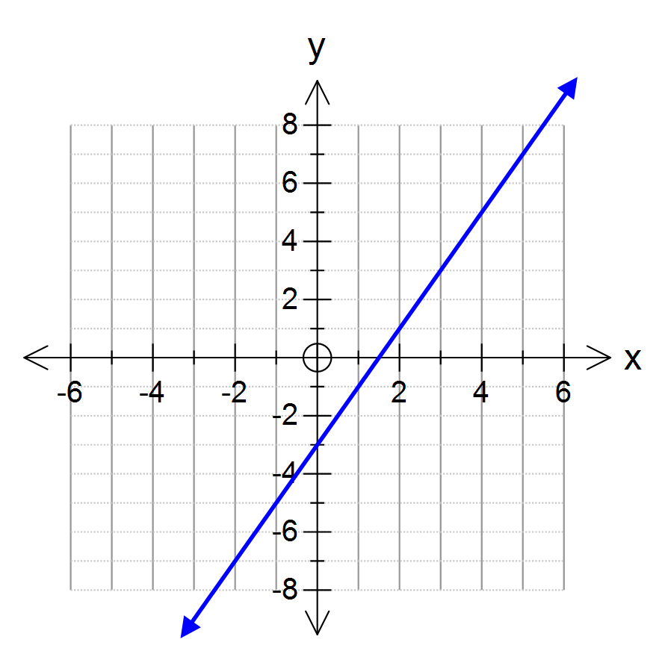 | b) | y = 5 - 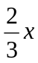  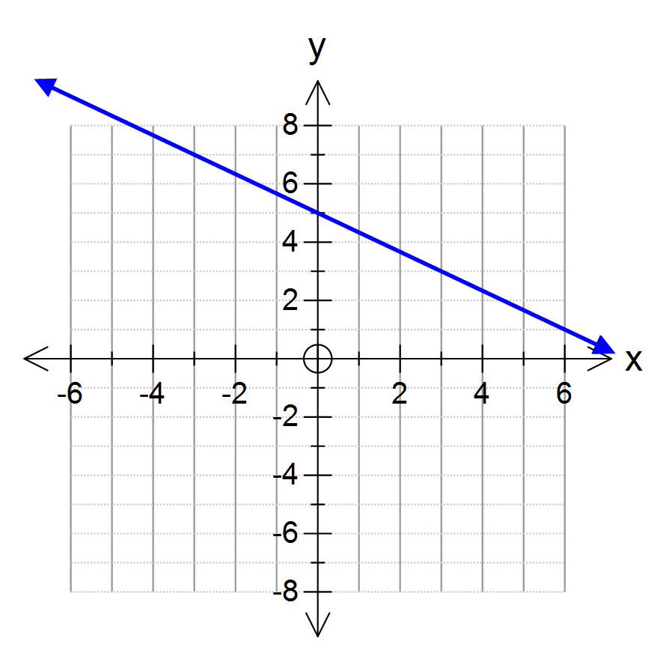
c) | 3x + y = 6  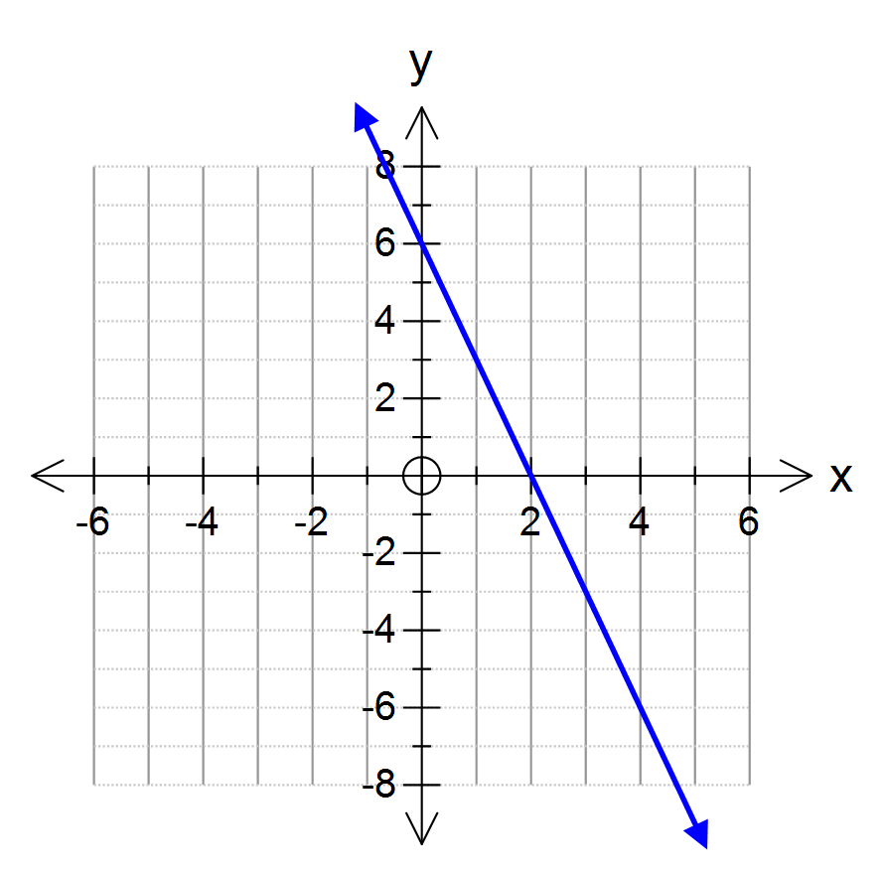 | d) | 4x – 3y = 12  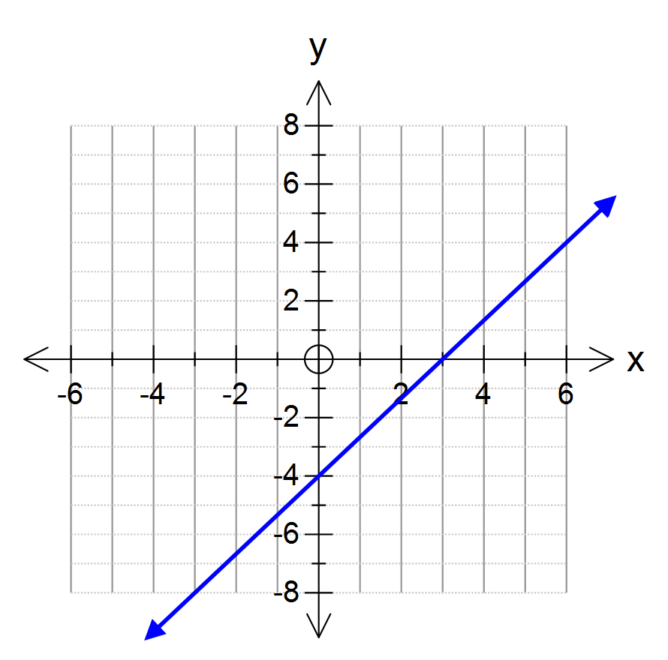

Mark allocation for each part:
Correct y intercept 
Correct x intercept 
Straight line between 

2. | [6 marks: 2, 2, 2]
 | Give the equations of the three lines in the graph on the right
a) | Line A  y = 2x-3 ✓✓ | 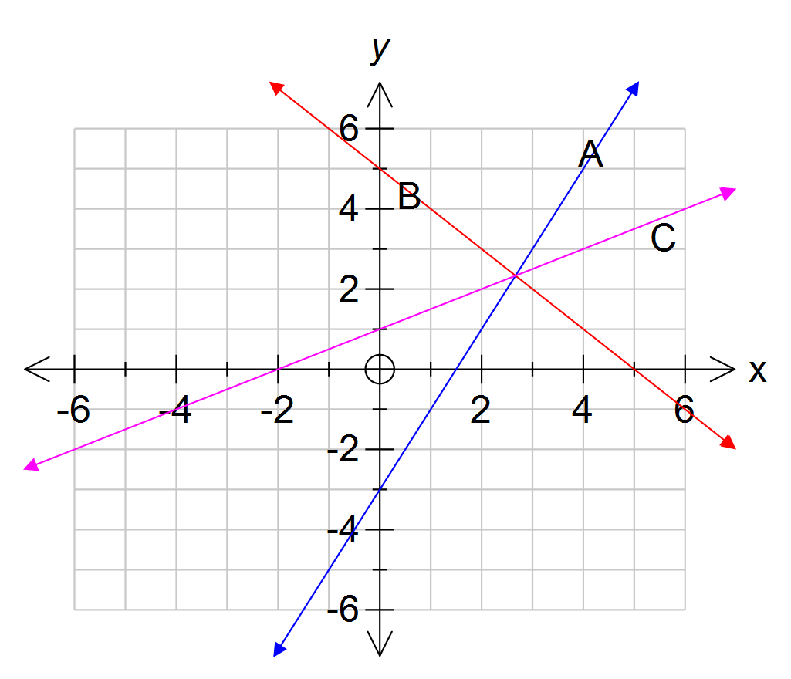
b) | Line B  y = 5 - x ✓✓
c) | Line C  y = x/2 + 1 ✓✓

3. | [6 marks: 2, 2, 2]
 | Give the equations of the three lines in the graph on the right
a) | Line A  y = 4✓✓ | 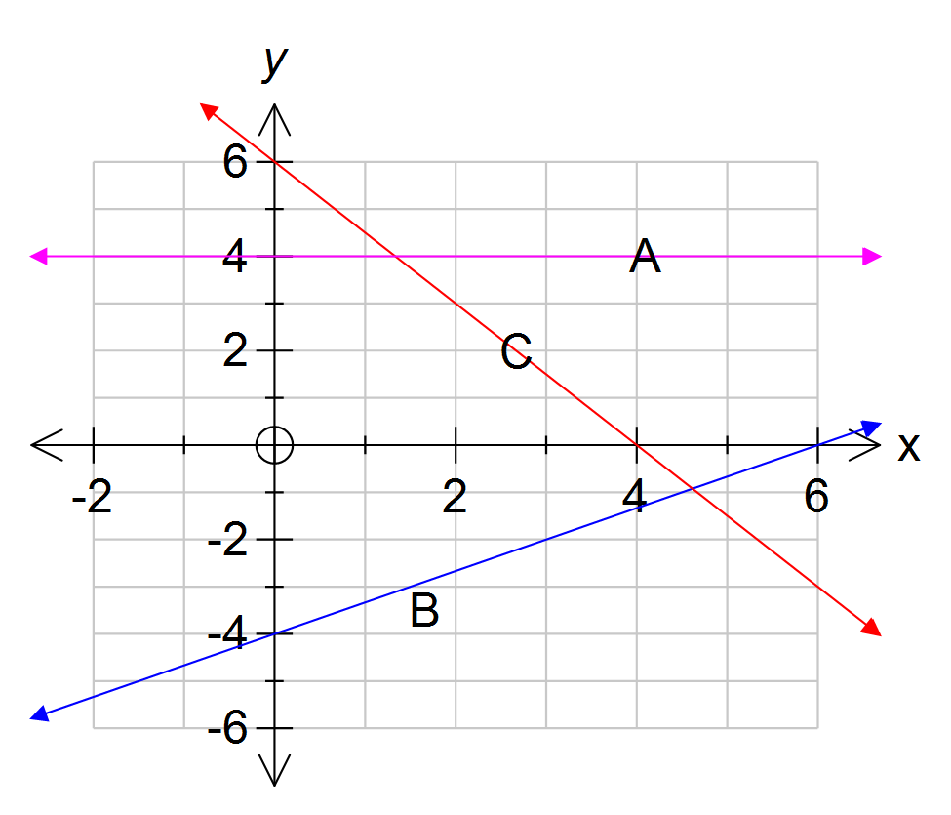
b) | Line B  y = 2x/3 - 4✓✓
c) | Line C  y = 6 - 3x/2 or -3x/2 + 6 ✓✓

Mark allocation a:
Correct equation 
(with no extra bits)

Mark allocation for b) & c):
Correct y intercept 
Correct gradient 

4. | [12 marks: 2, 2, 2, 2, 2, 2]
 | For each of the linear functions defined by the tables below, state the equation:-
a) | Equation is y = 4x + 6 Correct y gradient  Correct x intercept 
  x | 0 |  | 1 |  | 2 |  | 3 |  | 4 |  | 5 |  | 6
  y | 6 |  | 10 |  | 14 |  | 18 |  | 22 |  | 26 |  | 30
  First difference |  | 4 |  | 4 |  | 4 |  | 4 |  | 4 |  | 4
x | 0 |  | 1 |  | 2 |  | 3 |  | 4 |  | 5 |  | 6
y | 15 |  | 12 |  | 9 |  | 6 |  | 3 |  | 0 |  | -3
First difference |  | -3 |  | -3 |  | -3 |  | -3 |  | -3 |  | -3

Equation is y = -3x + 15 Correct y gradient  Correct x intercept 

c) | Equation is y = 9x + 7 Correct y gradient  Correct x intercept 
  x | 0 |  | 1 |  | 2 |  | 3 |  | 4 |  | 5 |  | 6
  y |  |  | 16 |  | 25 |  | 34 |  | 43 |  | 52 |  | 61
  First difference |  |  |  | 9 |  | 9 |  | 9 |  | 9 |  | 9
d) | Equation is y = 7x/2 – 10 Correct y gradient  Correct x intercept 
  x | 0 |  | 2 |  | 4 |  | 6 |  | 8 |  | 10 |  | 12
  y |  |  | -3 |  | 4 |  | 11 |  | 18 |  | 25 |  | 32
  First difference |  |  |  | 7 |  | 7 |  | 7 |  | 7 |  | 7
e) | Equation is y = -3x + 35 Correct y gradient  Correct x intercept 
  x | 3 |  | 6 |  | 9 |  | 12 |  | 15 |  | 18
  y | 29 |  | 23 |  | 17 |  | 11 |  | 5 |  | -1
  First difference |  | -6 |  | -6 |  | -6 |  | -6 |  | -6
f) | Equation is y = -2x + 157 Correct y gradient  Correct x intercept 
  x | 20 |  | 30 |  | 40 |  | 50 |  | 60 |  | 70 |  | 80
  y | 117 |  | 97 |  | 77 |  | 57 |  | 37 |  | 17 |  | -3
  First difference |  | -20 |  | -20 |  | -20 |  | -20 |  | -20 |  | -20

